Highlevel Architecture :

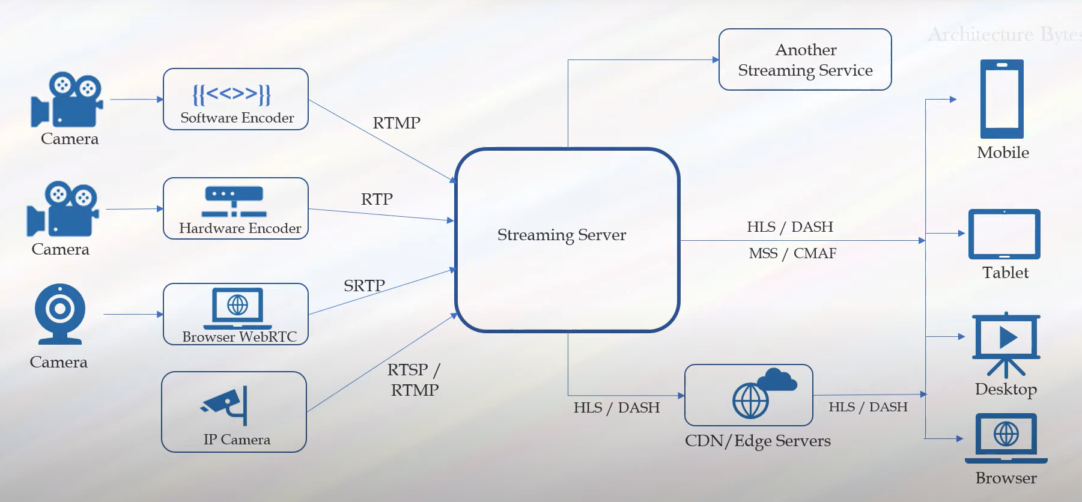

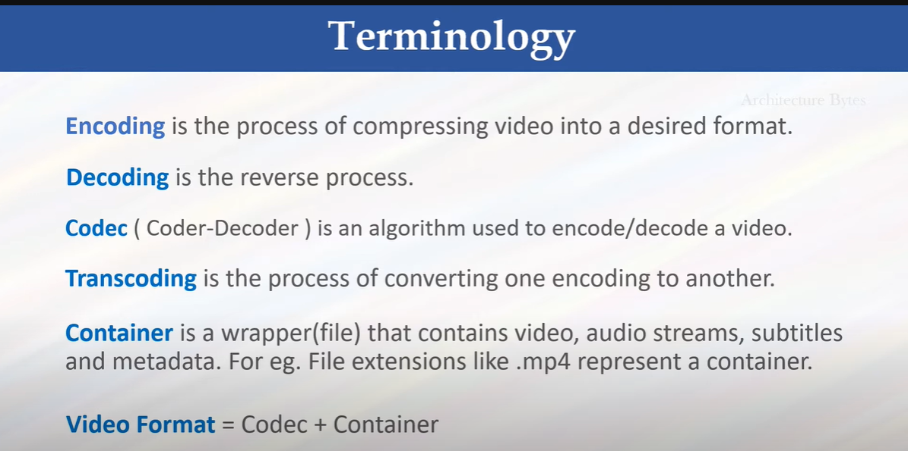

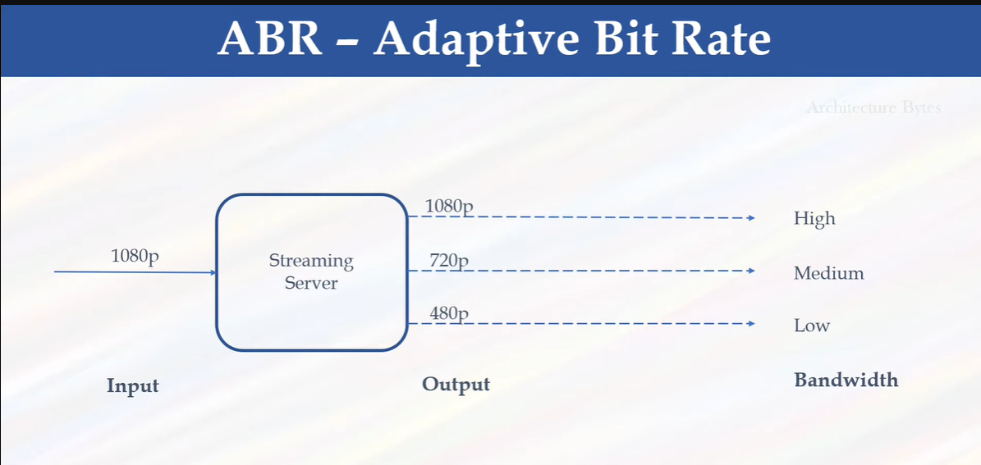

Dependenc on bandwidth or internet

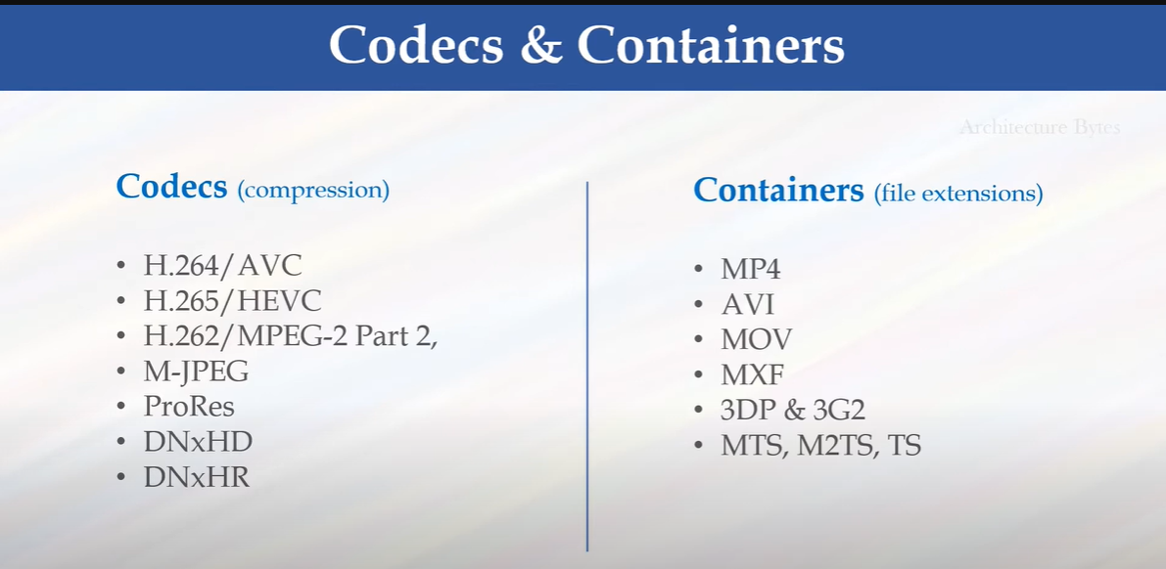

Media Protocols:

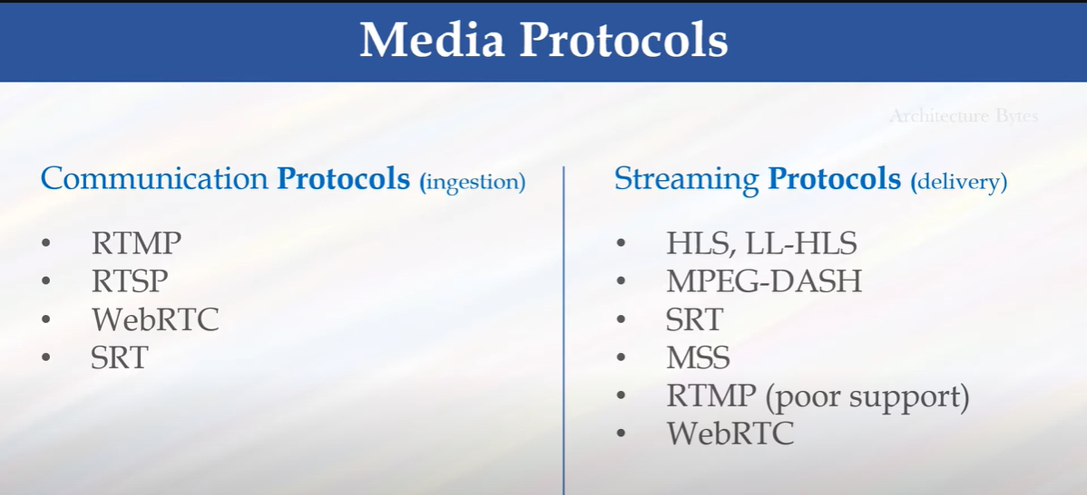

AWS Media Services :

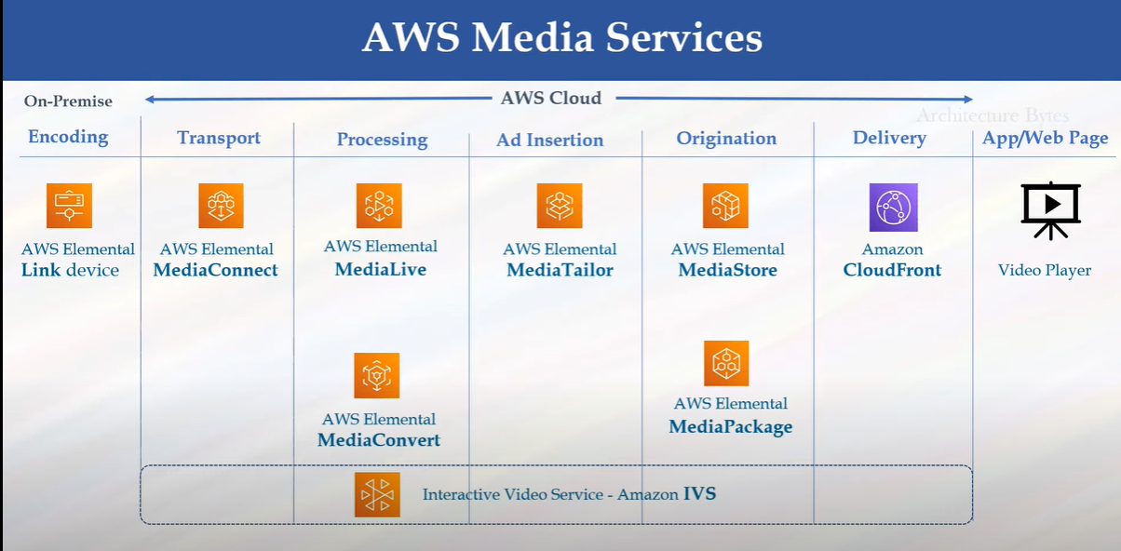

AWS Media services -Live streaming

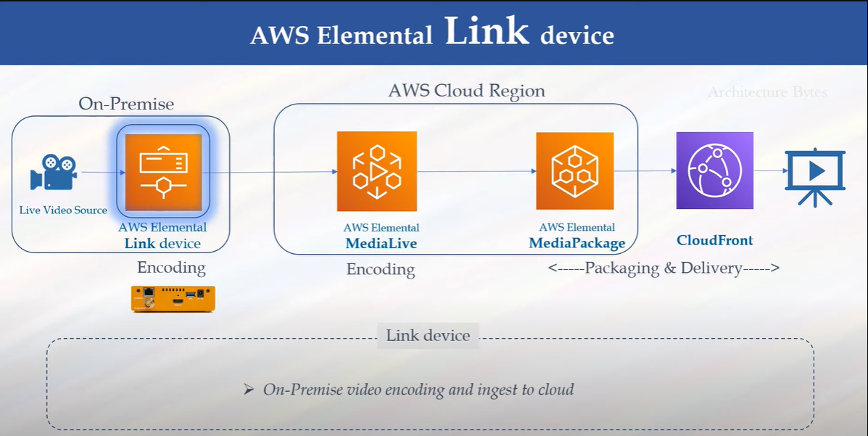

**What is AWS Elemental Link?**

* It’s a **small physical device** (looks like a TV set-top box) provided by AWS.
* Its job: **Send live video from your camera/studio to the AWS Cloud** (MediaLive service).
* Basically, it’s a **bridge** between your on-prem camera and AWS Cloud Playout/Streaming services.

**🔹 How it Works (Step by Step)**

1. **Connect Camera → Link**
   * Plug your camera or video source into the **HDMI/SDI input** on the Elemental Link device.
2. **Connect Link → Internet**
   * The device automatically connects to AWS over the internet.
   * No manual IP setup or firewall headache.
3. **AWS MediaLive Auto-Detects**
   * In your AWS Console, the device shows up automatically under **MediaLive inputs**.
4. **Start Streaming**
   * MediaLive takes the video feed from the Link device.
   * Then it encodes, processes, and sends it to destinations (OTT apps, social media, CDN).

**🔹 Key Features**

* **Plug-and-Play** → Just power it, connect to camera & internet.
* **Secure** → Video stream is encrypted directly to AWS.
* **Remote Managed** → Control via AWS console (no local UI).
* **High Quality** → Sends compressed but broadcast-quality video.
* **Low Cost** → No need for expensive encoders at the source.

**🔹 Where It Fits (Use Cases)**

* **Live Events** → Sports, concerts, corporate events.
* **News Feeds** → Reporters sending live video from field → Cloud.
* **OTT Channels** → Send studio feed into AWS playout/packaging pipeline.
* **Disaster Recovery** → Backup contribution feed to cloud.

**🔹 Workflow with Elemental Link**

🎥 **Camera/Studio Feed**  
➡️ **Elemental Link Device (on-premises)**  
➡️ **AWS MediaLive (cloud encoder/transcoder)**  
➡️ **MediaPackage / CloudFront (packaging & CDN)**  
➡️ **Viewers (OTT, social media, TV)**

👉 In short:  
**Elemental Link = Simple, secure “camera-to-cloud” device for AWS live streaming.**

WorkFlow Diagram :

camera → Link → MediaLive → MediaPackage → CloudFront CDN (Delivering Content or publishing or Distribution)

**AWS Media Connect:**

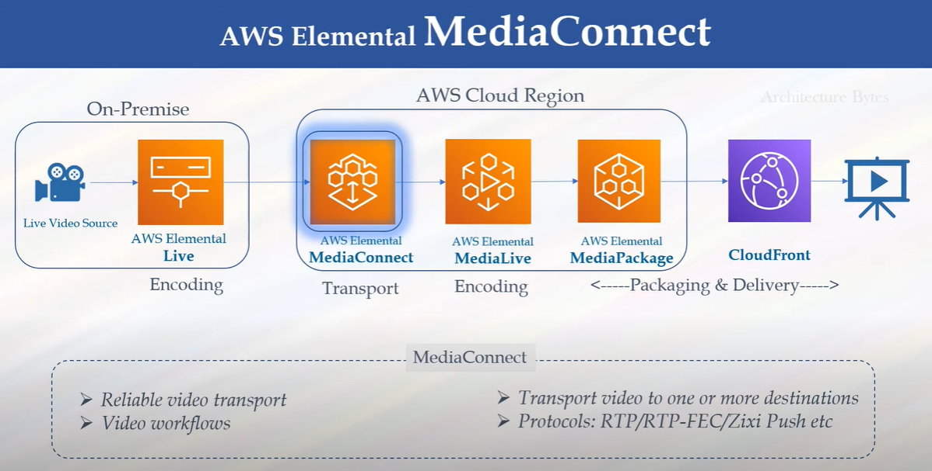

**What is AWS Elemental MediaConnect?**

* **MediaConnect = Cloud transport service for live video.**
* It lets you **send, receive, and share live video streams securely** across the internet or AWS backbone.
* Think of it as a **replacement for satellite/fiber contribution links**, but over IP and cloud.

**🔹 Why is it Needed?**

Traditional broadcasters use **satellite uplink or leased fiber lines** to move live video (sports, news, events). That’s expensive & less flexible.  
👉 MediaConnect makes this cheaper, faster, and **cloud-native**.

**🔹 Key Features**

1. **Reliable Contribution & Distribution**
   * Ingest live feeds into AWS from stadiums, studios, or affiliates.
   * Distribute live feeds to multiple partners or regions.
2. **Secure**
   * Uses **AES-256 encryption**.
   * Fine-grained entitlements → share feeds with other AWS accounts securely.
3. **Protocols Supported**
   * Zixi, RIST, RTP, SRT (low latency, reliable streaming).
4. **Flexible**
   * Spin up new connections in minutes.
   * Scale up/down depending on event demand.
5. **Integration with AWS Media Services**
   * Works with **MediaLive, MediaPackage, MediaStore, CloudFront**.

**🔹 How MediaConnect Works (Flow)**

1. **Contribution (Ingest)**
   * Bring live video into AWS from remote location (camera, production truck, studio).
2. **Transport (Within Cloud)**
   * MediaConnect delivers it to the right AWS region, account, or partner.
3. **Distribution (Output)**
   * Send to multiple destinations: broadcasters, OTT apps, affiliates.

**🔹 Example Use Cases**

* **Sports Broadcasting** → Capture stadium feed → MediaConnect → Distribute globally.
* **News Networks** → Share live feeds between affiliates.
* **Cloud Playout** → Input from MediaConnect → MediaLive → Channel output.
* **Remote Production** → Send feeds to editors/producers sitting anywhere in the world.

**🔹 Workflow Example**

🎥 Camera / OB Van Feed  
➡️ **MediaConnect (ingest & secure transport)**  
➡️ **MediaLive (encode/transcode)**  
➡️ **MediaPackage (prepare for OTT)**  
➡️ **CloudFront CDN (deliver to viewers)**

✅ **In short:**  
**MediaConnect = Cloud-based “video transport backbone” for broadcasters & OTT, replacing satellite/fiber with secure, flexible IP delivery.**

# **AWS Elemental Link vs MediaConnect**

| **Feature** | **Elemental Link** | **MediaConnect** |
| --- | --- | --- |
| **What it is** | A **physical device** that connects your camera/studio to AWS. | A **cloud service** that transports live video securely within AWS or to partners. |
| **Where it runs** | On-premises (in your studio, OB van, newsroom). | In the AWS Cloud. |
| **Main Job** | Contribution: **Camera → AWS MediaLive** (plug-and-play). | Distribution: **Move live streams securely between AWS regions/accounts/partners**. |
| **Input Source** | HDMI / SDI from camera or production switcher. | IP-based live streams (Zixi, RIST, SRT, RTP). |
| **Output** | Sends feed directly to **MediaLive**. | Sends feed to **MediaLive, MediaPackage, CloudFront, other AWS accounts**. |
| **Use Case** | Single location → AWS (uplink device). | Multi-location distribution (share live feeds globally). |
| **Cost Model** | One-time hardware purchase + AWS usage. | Pay-as-you-go for transport bandwidth/stream hours. |
| **Example** | Reporter plugs camera into Link → stream goes to AWS. | Sports broadcaster sends stadium feed → MediaConnect → affiliates in 10 regions. |

## 🔹 How They Work Together

* **Elemental Link** gets the video **into AWS**.
* **MediaConnect** moves that video feed **around the AWS cloud & to partners**.

👉 Example:  
🎥 Camera → **Elemental Link** → AWS MediaLive → **MediaConnect** → Affiliates (other broadcasters/OTT apps).

✅ **In short:**

* **Elemental Link = First-mile device (camera-to-cloud).**
* **MediaConnect = Cloud backbone for live video transport (cloud-to-cloud or cloud-to-partners).**

**AWS Media Live:**

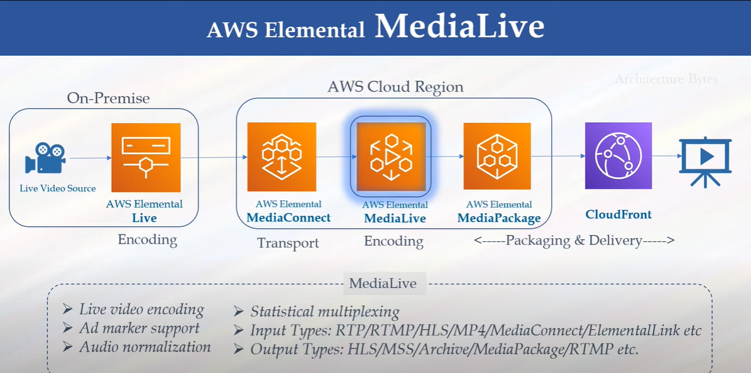

**What is AWS Elemental MediaLive?**

* **MediaLive = Cloud-based live video encoder/transcoder.**
* It takes a live video input (camera feed, satellite feed, or a stream) and converts it into **multiple video formats and bitrates** for distribution.
* Think of it as the **real-time video processing engine** inside AWS.

**🔹 Why it’s Needed**

* Viewers watch content on **different devices** (TV, mobile, laptop, OTT apps).
* Each device and network condition needs different formats and quality.  
  👉 MediaLive ensures **one live input → many optimized outputs**.

**🔹 Key Features**

1. **Live Encoding/Transcoding**
   * Converts raw feeds into **HLS, DASH, RTMP, CMAF, MPEG-TS**.
   * Adaptive Bitrate (ABR): multiple versions (1080p, 720p, 480p, 360p).
2. **High Availability**
   * Runs in **two Availability Zones** for failover.
   * Ensures 24/7 live channel uptime.
3. **Integration with AWS Media Services**
   * Works with **MediaConnect (input transport)**,  
     **MediaPackage (packaging & DRM)**,  
     **CloudFront (CDN delivery)**.
4. **Flexible Inputs/Outputs**
   * Inputs: RTMP, HLS, MediaConnect, Elemental Link.
   * Outputs: OTT (HLS/DASH), Broadcast (MPEG-TS), Social (YouTube, Facebook).
5. **Real-Time Graphics/Overlays**
   * Logo insertion, lower-thirds, captions, SCTE-35 ad markers.

**🔹 How MediaLive Works (Workflow)**

1. **Input Source** → Camera (via Elemental Link) / Feed (via MediaConnect).
2. **MediaLive** → Encodes/transcodes into ABR formats.
3. **Output to MediaPackage** → For packaging, DRM, multi-device streaming.
4. **Delivery via CloudFront CDN** → To OTT, web, mobile, smart TVs.

**🔹 Example Use Cases**

* **Live Sports Streaming** → One stadium feed → 5 different quality levels → millions of viewers.
* **24x7 OTT Channels** → TV broadcasters moving to cloud playout.
* **News Streaming** → Live reporter feeds to web & apps.
* **Corporate Events / e-Learning** → Stream live conferences, training sessions.

**🔹 AWS Media Services Ecosystem**

Here’s how **MediaLive fits in the bigger picture**:

🎥 **Camera / Studio**  
➡️ **Elemental Link / MediaConnect** (bring video to cloud)  
➡️ **MediaLive** (encode/transcode live video)  
➡️ **MediaPackage** (package + DRM + catch-up TV)  
➡️ **CloudFront CDN** (global delivery)  
➡️ 📱💻📺 Viewers (OTT, broadcast, social platforms)

✅ **In short:**  
**AWS MediaLive = Live video encoder in the cloud → transforms raw feeds into broadcast-quality multi-device streams.**

**WorkFlow** : showing Link/MediaConnect → MediaLive → MediaPackage → CloudFront → Viewers

**AWS Element Media Packaging:**

**Just-In-Time Packaging** = One video input → many output formats generated only when requested. Based on requesting Devices like phn tab lap and others

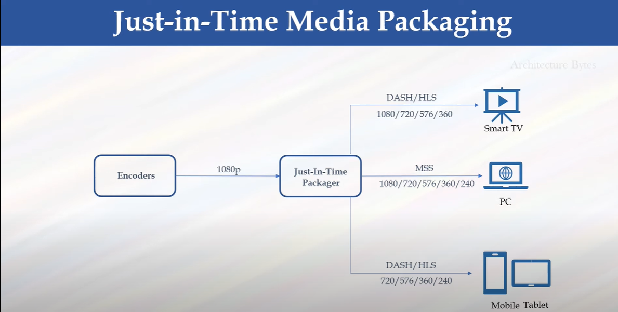

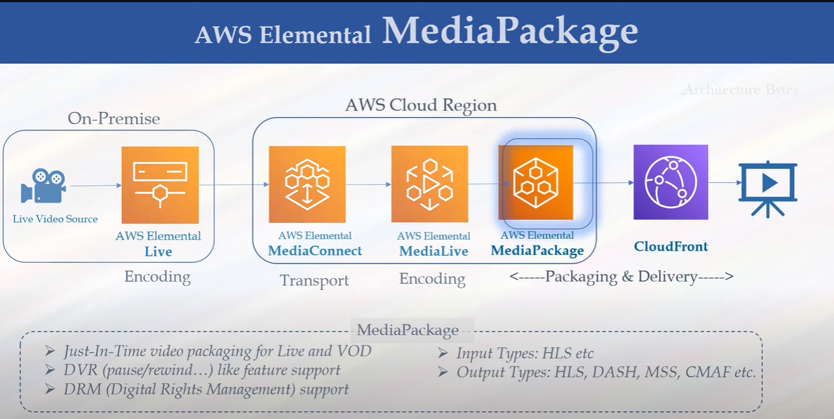

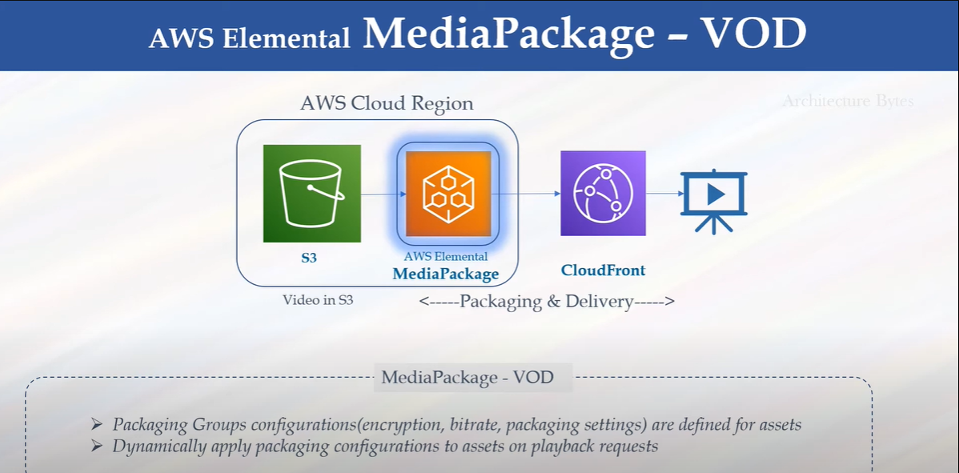

**What is AWS Elemental MediaPackage?**

* **MediaPackage = Cloud video origination & packaging service.**
* It prepares (packages) live or on-demand video into the correct formats for delivery to **different devices** (phones, TVs, browsers, set-top boxes).
* Supports **DRM, ad insertion, time-shift features, and Just-In-Time (JIT) packaging**.

👉 In simple words:  
It takes an **encoded stream from AWS MediaLive** and **packages it into HLS, DASH, CMAF, MSS** for global distribution via a CDN like CloudFront.

**🔹 Key Features**

1. **Multi-Format Packaging**
   * From a single input → outputs HLS, DASH, MSS, CMAF.
   * **Just-In-Time Packaging (JITP)** reduces cost & storage.
2. **Digital Rights Management (DRM)**
   * Integrates with Widevine, PlayReady, FairPlay.
   * Encrypts streams for secure OTT delivery.
3. **Time-Shift TV Features**
   * **Start-Over TV** → Restart live channel from the beginning.
   * **Catch-Up TV** → Watch past programs.
   * **Pause & Rewind Live TV**.
4. **Ad Insertion**
   * Works with SCTE-35 markers for **server-side ad insertion (SSAI)**.
   * Enables targeted ads for OTT.
5. **Scalable & Resilient**
   * Runs across multiple AWS Availability Zones.
   * High availability for 24/7 live channels.

**🔹 Workflow of MediaPackage**

🎥 **Live Source**  
➡️ **AWS Elemental MediaLive (encoding/transcoding)**  
➡️ **AWS MediaPackage (packaging + DRM + JITP + ads + time-shift)**  
➡️ **Amazon CloudFront (CDN)**  
➡️ 📱💻📺 **Viewers (OTT, web, mobile, TV, set-top boxes)**

**🔹 Example Use Cases**

* **OTT Platforms / FAST Channels** → Deliver content in multiple formats to different devices.
* **Live Sports Streaming** → Add DRM + targeted ads + rewind/catch-up.
* **24x7 Broadcasters** → Replace on-prem playout with cloud pipeline.
* **VOD Libraries** → Package on-demand content with JIT packaging + DRM.

✅ **In short:**  
**MediaLive = Encode**  
**MediaPackage = Package + Protect + Personalize (DRM, ads, time-shift)**  
**CloudFront = Deliver**

**WorkFlow :** (MediaLive → MediaPackage → CloudFront → Users)

**AWS media Store:**

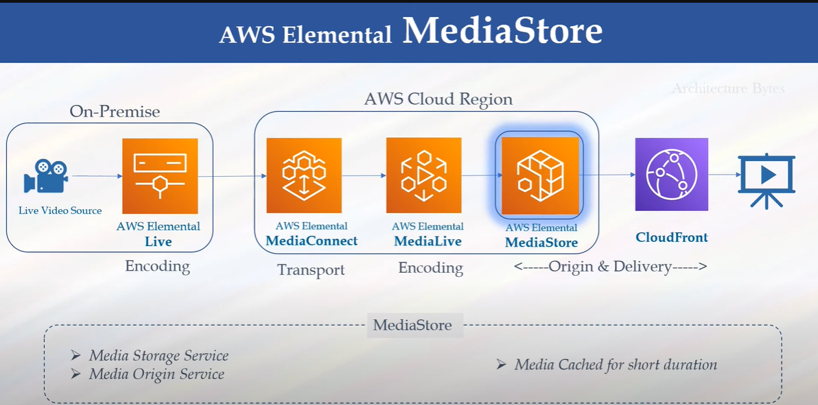

**What is AWS Elemental MediaStore?**

* **MediaStore = Cloud storage service optimized for live video.**
* It’s like Amazon S3, but **purpose-built for media workflows** (especially live streaming).
* Provides **low-latency, high-throughput, and video-friendly storage** for live channels.

👉 Think of it as a **"video-aware storage + origin server"** for live/OTT delivery.

**🔹 Why Not Just Use S3?**

* S3 is great for **archival and VOD**.
* But for **live video**, S3 can introduce higher latency.
* MediaStore solves this by offering:
  + **Millisecond latency** for segment writes/reads.
  + Optimized for **video chunked files** (HLS/DASH segments).
  + Acts as both **storage + CDN origin**.

**🔹 Key Features**

1. **Ultra-Low Latency**
   * Designed for live streaming — segments available to viewers immediately.
2. **Scalable Storage + Origin**
   * Stores live video segments & acts as origin for CDNs like **CloudFront**.
3. **Consistent Performance**
   * Handles millions of requests per second.
   * Optimized for small, frequent video segment uploads (2–6 sec chunks).
4. **Security**
   * Integrated with IAM, CloudWatch, and encryption.
5. **Cost-Efficient**
   * Cheaper for live stream origin than general object storage/CDN combos.

**🔹 Where MediaStore Fits in AWS Media Services**

🎥 **Live Source**  
➡️ **MediaLive (encoding/transcoding)**  
➡️ **MediaStore (store live segments, origin for CDN)**  
➡️ **CloudFront (CDN distribution)**  
➡️ 📱💻📺 **Viewers (OTT, web, TV)**

🔹 Optional:

* Use **MediaPackage** if you need **DRM, JIT packaging, time-shift, SSAI (ads)**.
* Use **MediaStore** if you want **simple, low-latency origin for live streaming**.

**🔹 Example Use Cases**

* **Live Sports / News** → Fast, reliable origin for millions of concurrent viewers.
* **Low-Latency OTT Channels** → Deliver live channels with <10s latency.
* **Disaster Recovery Origin** → Backup live stream origin.
* **Simple Live Streaming** → Without advanced packaging, just HLS/DASH via MediaStore + CloudFront.

✅ **In short:**

* **MediaStore = Video-optimized cloud storage + origin for low-latency live streams.**
* Use it when you need **fast, scalable, reliable live video delivery**.
* For **advanced features (DRM, ads, time-shift)** → use **MediaPackage**.

**When to Use**

* ✅ **MediaStore** → Use if you want **fast, simple, low-latency live streaming** with CloudFront, without advanced OTT features.
* ✅ **MediaPackage** → Use if you need **DRM, ad insertion, catch-up TV, multi-device support**.

👉 In many real-world deployments:

* **MediaLive → MediaPackage → CloudFront** = For **premium OTT channels** (sports, movies, broadcasters).
* **MediaLive → MediaStore → CloudFront** = For **simple/low-latency live streaming** (e.g., events, webinars, internal corporate streams).

AWS Media Convert :

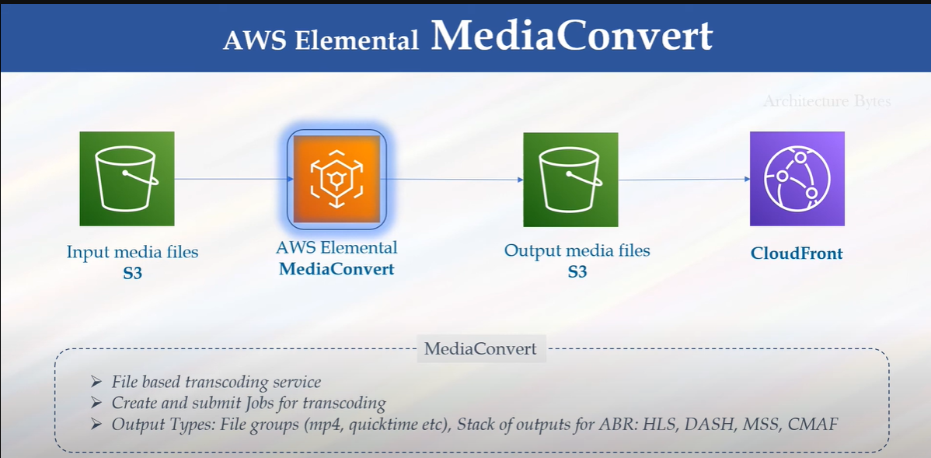

**What is AWS Elemental MediaConvert?**

* **MediaConvert = File-based video transcoding service.**
* It converts **stored media files (VoD)** into multiple formats and bitrates for playback on different devices.
* Unlike **MediaLive** (which handles **live streaming**), **MediaConvert is for Video-on-Demand (VOD)**.

👉 Example: You upload a movie in **.mov** or **.mp4**, MediaConvert outputs multiple versions (HLS, DASH, CMAF, MPEG-TS) optimized for mobile, TV, web.

**🔹 Key Features**

1. **Multi-Format Transcoding**
   * Inputs: MP4, MOV, MXF, MPEG-2, AVI, etc.
   * Outputs: HLS, DASH, CMAF, MPEG-TS, MP4.
2. **Adaptive Bitrate (ABR) Packaging**
   * Automatically creates multiple quality levels (1080p, 720p, 480p, 360p).
   * Ensures smooth playback for users on different networks.
3. **DRM & Encryption**
   * Integrates with **Widevine, PlayReady, FairPlay**.
   * Protects premium OTT content.
4. **Advanced Video Features**
   * 4K Ultra HD, HDR10, Dolby Vision.
   * Audio normalization, Dolby Atmos.
   * Closed captions & subtitling.
5. **File-Based Workflows**
   * Batch transcoding of large VoD libraries.
   * Automated workflows using S3 + Lambda + Step Functions.

**🔹 How MediaConvert Works (Workflow)**

1. **Input Files**
   * Upload raw media files into **Amazon S3**.
2. **MediaConvert Job**
   * Define a **transcoding job template** (output formats, bitrates, captions, DRM).
   * MediaConvert processes the files in the cloud.
3. **Outputs**
   * Packaged streams (HLS, DASH, CMAF) + MP4.
   * Stored back into **S3**.
4. **Delivery**
   * Distributed to users via **CloudFront CDN** or any OTT platform.

**🔹 Example Use Cases**

* **OTT Platforms (Netflix-like)** → Convert movies into multi-bitrate streaming versions.
* **Broadcasters** → Prepare TV shows for VoD apps.
* **E-Learning Platforms** → Convert training videos for different devices.
* **Enterprises** → Compress corporate videos for web delivery.

**🔹 AWS Media Services Ecosystem (Where MediaConvert fits)**

* **MediaLive** → Live encoding (real-time).
* **MediaPackage** → Just-in-time packaging (live/VOD).
* **MediaStore** → Low-latency storage for live streams.
* **MediaConvert** → **File-based transcoding (VOD content prep).**

✅ **In short:**  
**MediaConvert = Converts raw media files into OTT-ready formats (for VOD).**  
**MediaLive = Converts live feeds into streaming formats (for Live TV).**

AWS Media Trailor :

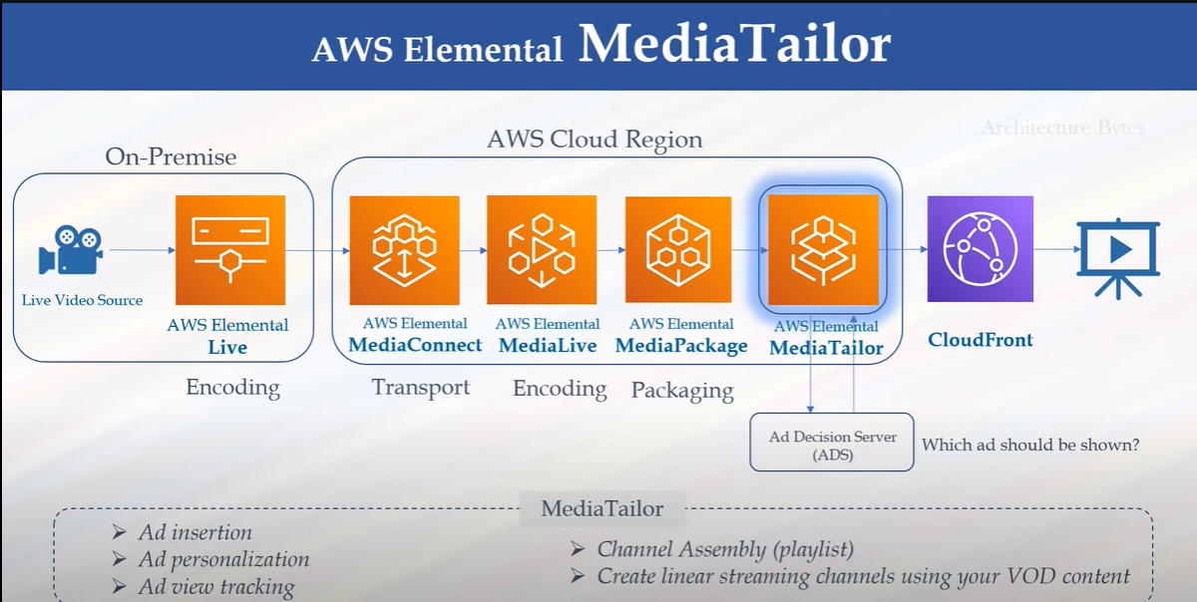

**What is AWS Elemental MediaTailor?**

* **MediaTailor = AWS service for server-side ad insertion (SSAI) + content personalization.**
* It lets broadcasters and OTT platforms insert **targeted ads** into live or on-demand video streams **seamlessly**.
* Ads are stitched into the video stream in the **cloud**, so the viewer’s device sees one continuous video (not separate ad breaks).

👉 In simple words:  
Instead of sending the same ad to everyone, MediaTailor enables **personalized ads** based on the viewer’s location, device, or profile.

**🔹 Key Features**

1. **Server-Side Ad Insertion (SSAI)**
   * Inserts ads into the video stream at the **server level** (not client level).
   * No buffering during ad playback.
2. **Personalized Ads**
   * Works with ad decision servers (ADS) and SCTE-35 markers.
   * Supports targeting by region, device, demographics.
3. **Seamless Playback**
   * Viewer sees a single continuous stream (ads + content).
   * Works on all devices without special players.
4. **Ad Tracking & Reporting**
   * Supports industry standards (VAST, VMAP, VPAID).
   * Publishers can measure ad impressions accurately.
5. **Scalable & Cost-Effective**
   * Works at any scale (from 1 channel → 1000s).
   * Pay per stream and ad decision requests.

**🔹 How MediaTailor Works (Flow)**

1. **Input Stream** → From **MediaLive/MediaPackage** with SCTE-35 ad markers.
2. **MediaTailor** → Contacts **Ad Decision Server (ADS)** to request targeted ads.
3. **Ad Stitching** → Ads are transcoded & stitched into the live/VOD stream.
4. **Output Stream** → Packaged as HLS/DASH → sent to **CloudFront CDN**.
5. **Viewers** → Watch a continuous stream with personalized ads.

**🔹 Example Use Cases**

* **OTT Platforms / FAST Channels** → Pluto TV, Hotstar, Zee5 using targeted ads.
* **Broadcasters** → Replace traditional TV ads with digital targeted ads.
* **Sports Streaming** → Insert region-specific ads (e.g., Indian ads for Indian viewers, US ads for US viewers).
* **AVOD Services (Ad-supported VOD)** → Deliver free content monetized by ads.

**🔹 Where MediaTailor Fits in AWS Media Services**

🎥 **Camera / VOD Library**  
➡️ **MediaLive / MediaConvert** (encode)  
➡️ **MediaPackage** (package + DRM + time-shift)  
➡️ **MediaTailor** (ad insertion + personalization)  
➡️ **CloudFront CDN**  
➡️ 📱💻📺 **Viewers (see personalized ads in stream)**

✅ **In short:**  
**MediaTailor = Monetization layer** in AWS Media Services → provides **ad insertion + targeting + reporting** for live & VOD video.

AWS IVS(interactive video service):

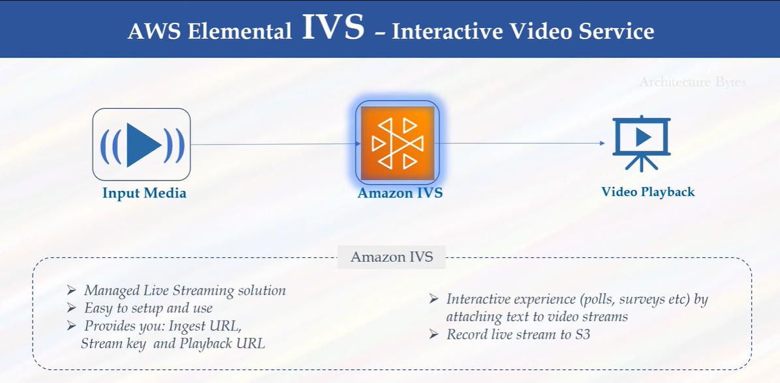

**What is Amazon IVS?**

* **Amazon Interactive Video Service (IVS)** is a **managed live streaming service** from AWS.
* It is built on the same technology that powers **Twitch** (Amazon’s live streaming platform).
* With IVS, you can **easily add low-latency live video** to websites and apps **without building complex streaming infrastructure**.

👉 Think of it as:

* **MediaLive** = professional broadcast-grade streaming (TV, OTT).
* **IVS** = fast, simple, interactive streaming (apps, gaming, e-commerce, events).

**🔹 Key Features**

1. **Ultra Low Latency**
   * ~2–3 seconds delay (compared to 20–30 sec in HLS).
   * Enables **real-time interactivity** between streamers and viewers.
2. **Easy to Integrate**
   * Comes with **SDKs and APIs** for web, iOS, Android.
   * No need to manage encoders, packagers, or CDNs manually.
3. **Scalable & Managed**
   * AWS handles **ingest, transcoding, packaging, and global delivery**.
   * Scales automatically to thousands or millions of viewers.
4. **Interactive Features**
   * **Timed metadata** → Sync polls, quizzes, live stats with video.
   * Viewers can **chat, vote, or shop** while watching the stream.
5. **Monetization & Analytics**
   * Combine with **MediaTailor** for ads.
   * Capture metrics (viewers, watch time).

**🔹 How IVS Works**

1. **Broadcast (Input)**
   * Streamer uses OBS, Streamlabs, or mobile camera → sends RTMPS stream to IVS.
2. **Processing**
   * IVS automatically **transcodes** into multiple bitrates.
   * Packages into low-latency HLS.
3. **Delivery**
   * Video delivered via IVS **playback URL** (HLS link).
   * Integrated into apps/websites with SDK or video player.
4. **Viewer Experience**
   * Viewers watch in near real-time.
   * Developers can sync **polls, chat, Q&A, shopping links** with video.

**🔹 Example Use Cases**

* 🎮 **Gaming / eSports** → Stream matches with real-time chat.
* 🛍️ **Live Shopping** → Amazon-style product demos with instant buying.
* 🎓 **Education** → Interactive classes with Q&A.
* 🎤 **Events & Concerts** → Global live events with audience participation.
* 📰 **News / Townhalls** → Live announcements with polls or feedback.

**🔹 IVS vs Other AWS Media Services**

| **Service** | **Use Case** | **Latency** | **Best For** |
| --- | --- | --- | --- |
| **MediaLive** | Broadcast-grade live encoding | 10–30 sec | TV, OTT, 24/7 channels |
| **IVS** | Interactive live streaming | 2–3 sec | Apps, gaming, events, shopping |
| **MediaConvert** | File-based VoD transcoding | N/A | On-demand video |
| **MediaPackage** | Just-in-time packaging + DRM | Standard (10–30 sec) | OTT delivery |
| **MediaTailor** | Ad insertion | N/A | Monetization |

✅ **In short:**  
**Amazon IVS = Simple, low-latency, interactive live streaming service built for apps and websites.**  
It’s best when you need **real-time engagement** (gaming, shopping, education), while **MediaLive** is better for professional broadcast/OTT.

**Architecture :** Live Streaming

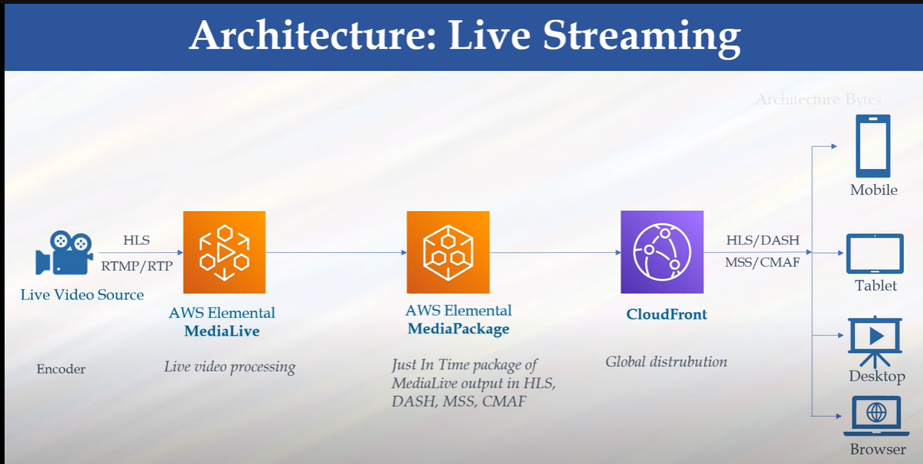

Or

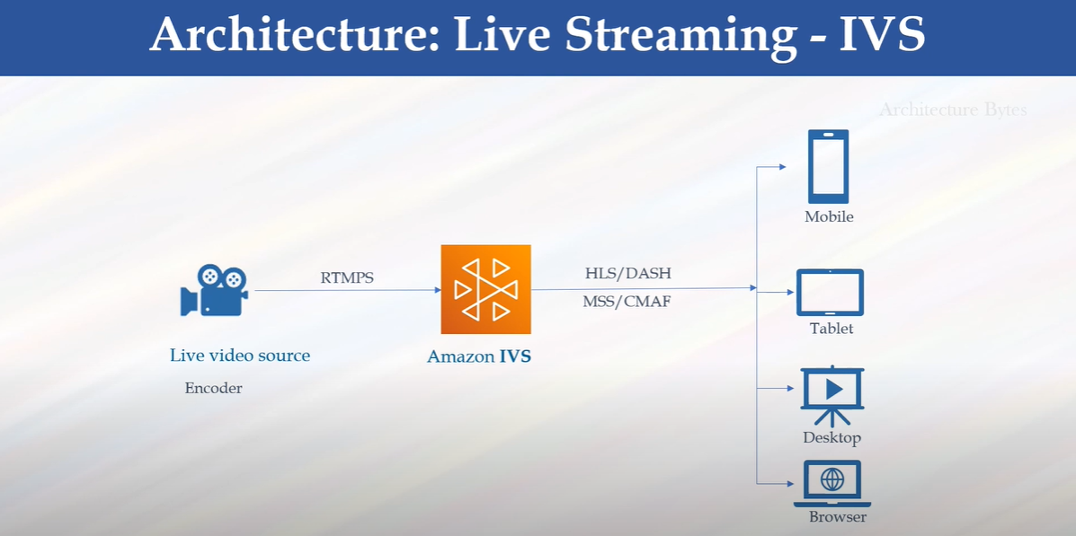

Or

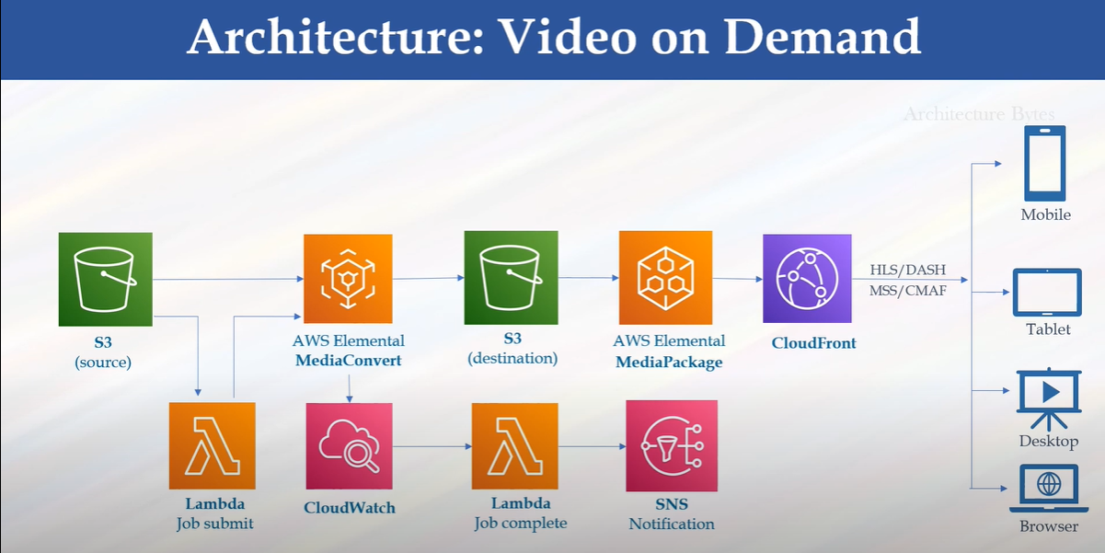

## 1️⃣ ****Basic Live Streaming (Low Latency – Simple)****

* **Workflow**:  
  Camera → **MediaLive** (encode) → **MediaStore** (origin) → **CloudFront** (CDN) → Viewers
* **Use Case**: Sports, webinars, news events (when DRM/ads not needed).
* **Latency**: ~3–5 seconds.

## 2️⃣ ****Live Streaming with Advanced OTT Features****

* **Workflow**:  
  Camera → **MediaLive** (encode) → **MediaPackage** (packaging, DRM, time-shift) → **CloudFront** → Viewers
* **Use Case**: Professional TV channels, OTT platforms (Hotstar, JioCinema style).
* **Features**: DRM, catch-up TV, pause/rewind, multi-device support.
* **Latency**: 10–30 seconds (HLS/DASH).

## 3️⃣ ****Low-Latency Interactive Streaming (IVS)****

* **Workflow**:  
  Camera/App → **IVS Ingest** → **IVS Processing + Playback URL** → App/Web Player (with SDK)
* **Use Case**: Gaming (Twitch), Live shopping, e-learning, Q&A sessions.
* **Latency**: ~2–3 seconds.
* **Highlight**: Interactive features (polls, chat, metadata sync).

## 4️⃣ ****Video on Demand (VOD)****

* **Workflow**:  
  File Upload → **S3** → **MediaConvert** (transcode into HLS/DASH) → **S3 (output)** → **CloudFront** → Viewers
* **Use Case**: Netflix-like services, training libraries, e-learning.
* **Features**: Multi-bitrate, multi-device playback.

## 5️⃣ ****Live + VOD Hybrid (Catch-Up TV / Replay)****

* **Workflow**:  
  Camera → **MediaLive** → **MediaPackage** (live stream) → **CloudFront**
  + Simultaneously → **MediaConvert** (create VoD assets) → **S3** → **CloudFront**
* **Use Case**: Sports, where users watch **live** or **replay highlights**.
* **Features**: Live + VOD library integration.

## 6️⃣ ****Monetized Streaming (Ad Insertion)****

* **Workflow**:  
  Camera → **MediaLive** → **MediaPackage** → **MediaTailor** (server-side ad insertion) → **CloudFront** → Viewers
* **Use Case**: OTT apps needing revenue from ads (sports, news, live TV).
* **Features**: Personalized ads per user, SCTE-35 cue marker support.

## 7️⃣ ****Broadcast Contribution & Distribution****

* **Workflow**:  
  On-prem Encoder / Playout → **MediaConnect** (secure transport) → AWS Media Services → (MediaLive / MediaPackage / CloudFront) → Distribution networks (cable, OTT, affiliates)
* **Use Case**: Broadcasters sending feeds from studios to AWS or affiliates.
* **Features**: Reliable transport (Zixi, RIST, RTP), global distribution.

# 🔹 Visual Summary (Text Form)

1. **Basic Live (MediaLive + MediaStore)** → Low-latency OTT.
2. **OTT Live (MediaLive + MediaPackage)** → Premium TV, DRM, catch-up.
3. **Interactive (IVS)** → Gaming, shopping, events.
4. **VOD (S3 + MediaConvert)** → Netflix-style on-demand.
5. **Hybrid (Live + VOD)** → Sports with replays.
6. **Monetized (MediaTailor)** → Ad-supported streaming.
7. **Broadcast Contribution (MediaConnect)** → Studio-to-cloud transport.